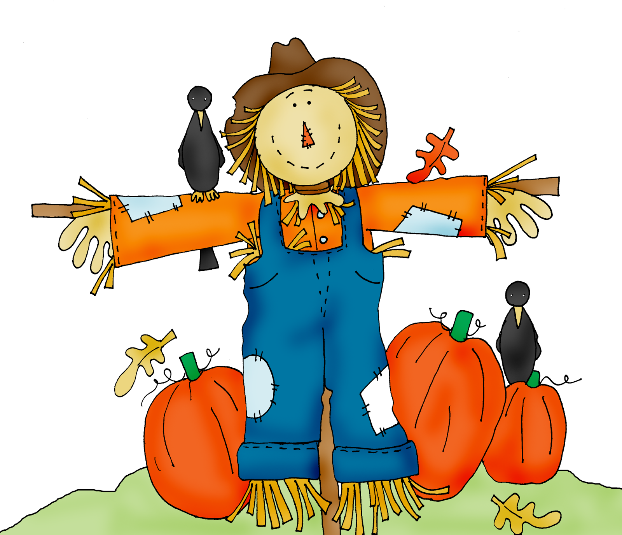
2022 Morgan County
Squarecrow Showcase

Sponsor Letter

Hosted by

Morgan County Tourism Alliance

Fall is just around the corner and plans are underway for our 3rd Annual Squarecrow Showcase!

October 10 - November 15, 2022

The contest is open to all individuals/families, businesses, schools, churches, non-profit organizations, clubs and government offices in Morgan County and surrounding areas.

This year, Squarecrows will be displayed on and around the historic Wartburg Square which will surely attract visitors viewing the Squarecrows and casting votes for the “People’s Choice Award”.

This year’s contest promises to be a huge draw for the community with prizes totaling $150!

We hope you will consider becoming a Sponsor for this month-long fun-filled, family event fostering community spirit, attracting hundreds of visitors to the area and promoting Morgan County businesses.

All Sponsors pledging $100.00 or more will be listed as a sponsor on the event website plus receive a free prime location on the square for their Squarecrow if they wish to enter a Squarecrow in the contest. Sponsor checks should be made payable to Morgan County Tourism Alliance. and delivered with the entry form to the Morgan County Tourism Alliance office located at Tanner’s Store at 201 Court Street, Wartburg, TN 37887.

For additional information about the contest/registration form and a set of the contest rules go to the Morgan County Tourism Alliance website on or after September 1st, 2021 at https://www.mctamoco.com or contact showcase organizer George Hawver at 770-634-4263..

Sponsorship deadline: 10/10/2022

Thank you so much for your support!

